**Assignment-3**

| Assignment Date | 19 September 2022 |
| --- | --- |
| Student Name | GAJAPATI.VE.S |
| Student Roll Number | 611219104019 |
| Maximum Marks | 2 Marks |

Write a python program for Blinking LED light and Traffic light for raspberry pi

TRAFFIC LIGHT CODE

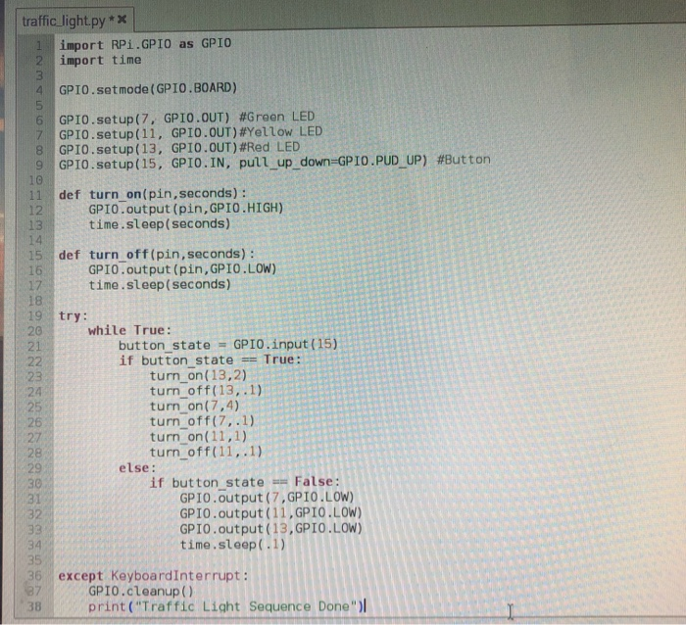

PYTHON CODE FOR BLINK LED

